ASSIGNMENT (LAB 2)

Question no; 01 (code)

#include<iostream>

using namespace std;

int main()

{

int num1,num2; float num3;

cout<<"please enter two integer and one decimal number: "<<endl;

cin>>num1>>num2>>num3;

cout<<num1<<" "<<num2<<" "<<num3<<endl;

return 0;

}

Question no; 01 (output)

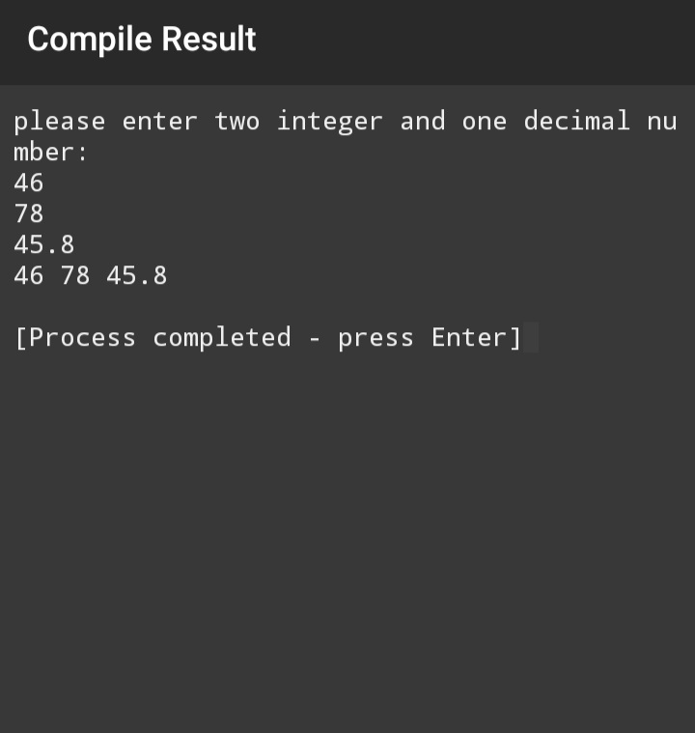

Question no; 02 (code)

#include<iostream>

using namespace std;

int main()

{int num;

cout <<"Enter five digit integer number\n";

cin>>num;

cout<< num%10<<endl;

cout<<num%100/10<<endl;

cout<<num%1000/100<<endl;

cout <<num%10000/1000<<endl;

cout <<num%100000/10000<<endl;

return 0;}

Question no; 02 (output) 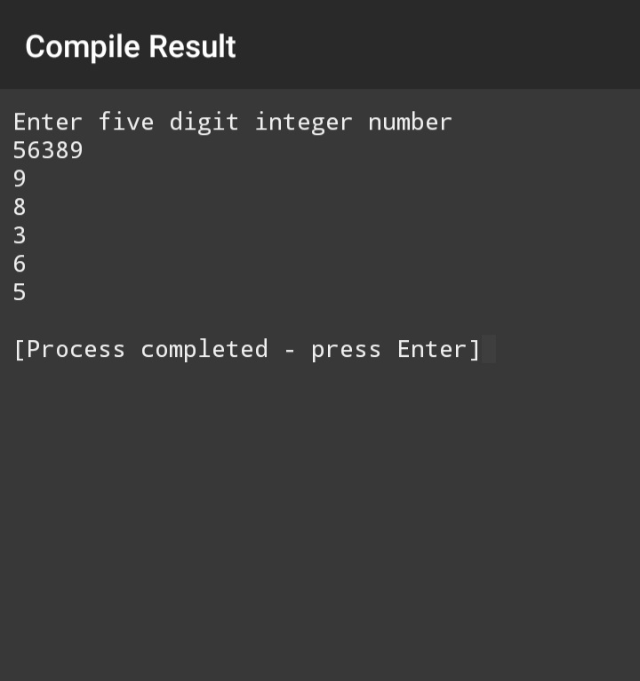

Question no: 03 (code)

#include<iostream>

using namespace std;

int main()

{

int total_amount;

cout << "please enter the total amount:\n";

cin>>total_amount;

cout<<"zakat paid on total amount is ";

cout<<total_amount*2.5/100;

return 0;

}

Question no; 03 (output)

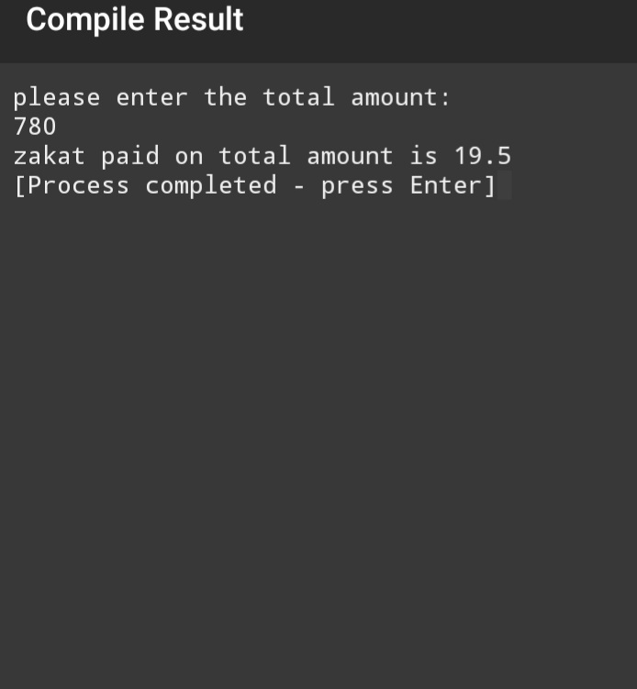

Question no: 04 (code)

#include<iostream>

using namespace std;

int main()

{

float initial_velocity;

float acceleration;

float final_velocity;

cout << "please enter initial velocity: \n";

cin>>initial_velocity;

cout<<"please enter acceleration: \n";

cin>>acceleration;

cout<<"Final velocity= ";

final_velocity=initial_velocity+acceleration;

cout<<final_velocity;

return 0;}

Question no; 04 (output)

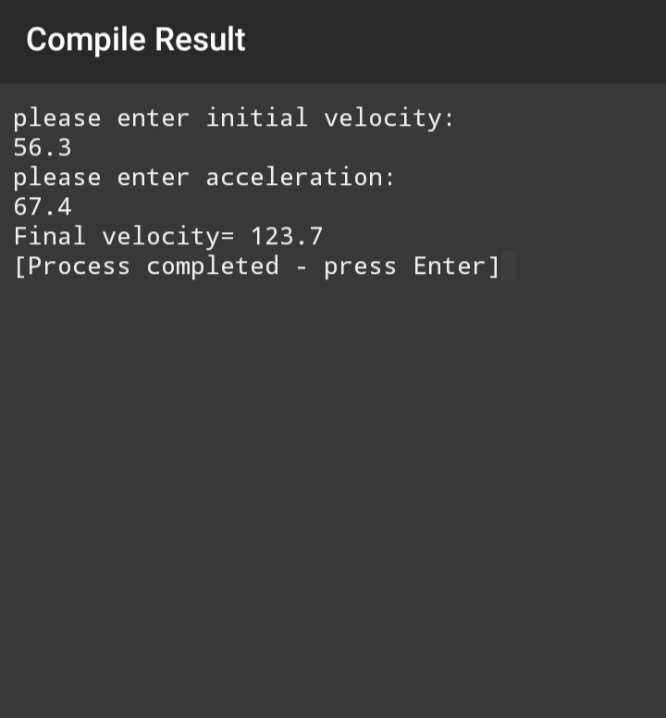

Question no: 05 (code)

#include<iostream>

using namespace std;

int main()

{

float distance;

float time;

float speed;

cout << "please enter the distance: \n";

cin>>distance;

cout<<"please enter the time: \n";

cin>>time;

cout<<"speed= ";

speed=distance/time;

cout<<speed;

return 0;}

Question no; 05 (output)

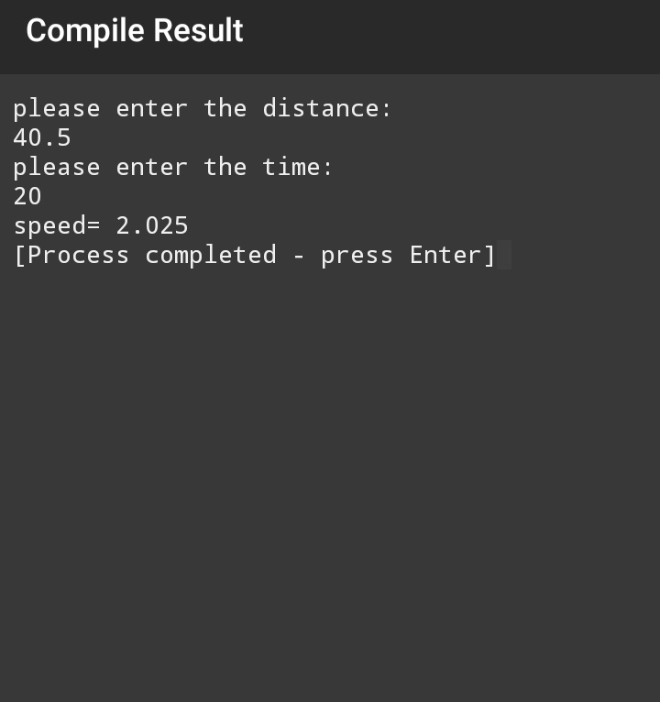

Question no: 06 (code)

#include<iostream>

using namespace std;

int main()

{

double a,b,x;

cout << "please enter the value of a: \n";

cin>>a;

cout<<"please enter the of b: \n";

cin>>b;

cout<<"x= ";

x=2*(a+b)-2*a*b;

cout<<x;

return 0;

}

Question no; 06 (output)

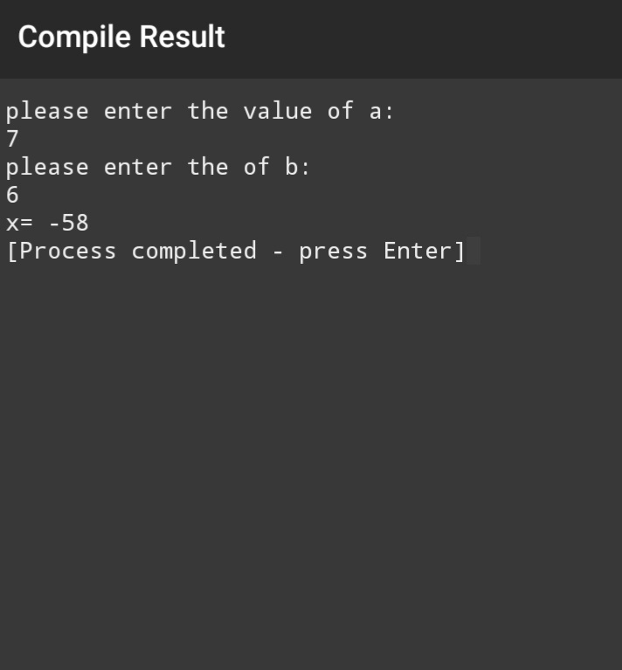

Question no: 07 (code)

#include<iostream>

using namespace std;

int main()

{

cout<<" MARKSHEET \n";

int sub1,sub2,sub3,sub4,sub5,obtained_marks,percentage;

cout << "enter the marks of sub1 \n";

cin>>sub1;

cout << "enter the marks of sub2 \n";

cin>>sub2;

cout << "enter the marks of sub3 \n";

cin>>sub3;

cout << "enter the marks of sub4 \n";

cin>>sub4;

cout << "enter the marks of sub5 \n";

cin>>sub5;

cout<<"obtained_marks=";

obtained_marks=sub1+sub2+sub3+sub4+sub5;

cout<<obtained_marks<<endl;

cout<<"percentage=";

percentage=obtained_marks*100/500;

cout<<percentage;

return 0;

}

Question no; 07 (output)

